1.
Draw a simple network diagram showing three devices (like your laptop, a friend's phone, and a smart TV) connected to a switch, and label which device is in which VLAN (e.g., VLAN 10 for streaming, VLAN 20 for personal devices).
+------------------+
| Switch |
+------------------+
| Fa0/1 - VLAN 20
| Fa0/2 - VLAN 20
| Fa0/3 - VLAN 10
+------------------+
| | |
| | |
+-----+ +---+--+ +------+
|Laptop| |Phone| |Smart TV|
+-----+ +------+ +------+
VLAN20 VLAN20 VLAN10
(Personal) (Personal) (Streaming)

2.
Configure a simulated switch using Cisco Packet Tracer or NetSim: create two VLANs (VLAN 10 and VLAN 20), assign three PCs to VLAN 10 and two PCs to VLAN 20, and verify that PCs in different VLANs cannot ping each other.<br><br><em><strong>Hint:</strong> Use the 'vlan' and 'switchport access vlan' commands in the simulator CLI.</em>
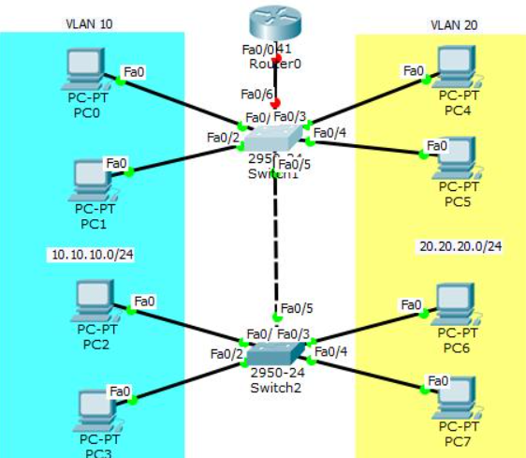
3.
In any network simulator, set up a scenario where you move a PC from VLAN 10 to VLAN 20. Show the before and after configuration commands and test connectivity to confirm the change.
Before configuration:
interface fa0/1
switchport access vlan 10
After configuration:
enable
configure terminal
interface fa0/1
switchport access vlan 20
exit
end
Change PC0 IP address:
- Old: 192.168.10.1
- New: 192.168.20.3
Testing:
- Ping VLAN 20 PC → Successful.
- Ping VLAN 10 PC → Failed.

4.
Write a short script or command list that would automate assigning 10 ports on a switch to VLAN 30, using the syntax of your chosen simulator (Packet Tracer, NetSim, or GNS3).<br><br><em><strong>Constraint:</strong> Use a loop or range command if supported by the tool to avoid repeating the same command 10 times.</em>
Command | Use
vlan 10 | Create VLAN 10
show vlan brief | Display VLANs
interface fa0/1 | Select one port
interface range fa0/1-10 | Select 10 ports
switchport access vlan 10 | Assign VLAN
switchport mode access | Set access mode

